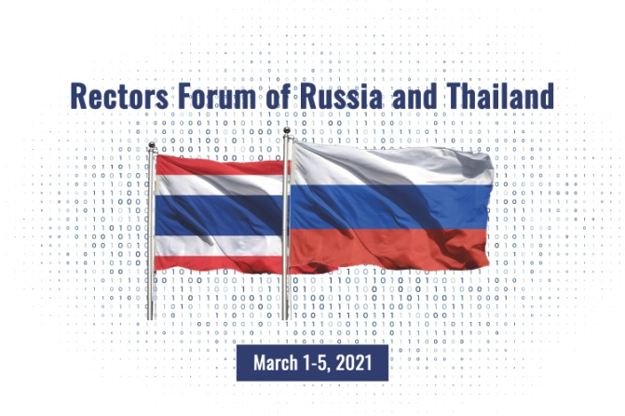
The First Rectors Forum of Russia and Thailand
“Education in Russia and Thailand: Dialogue with the Digital Society”

March 1-5th, 2021

Organizers: | Russian Union of Rectors  St. Petersburg State University of Economics (UNECON)  Lomonosov Moscow State University
Supported by: | Embassy of the Russian Federation in Thailand  St. Petersburg Government  Assembly of St. Petersburg Rectors

Friendly diplomatic relations between Russia and the Kingdom of Thailand date back more than 120 years. Economic, political and social relations between the countries are developing with the growing goods exchange, touristic flow and strengthening cultural relations. Today, the entire region of Southeast Asia, including Thailand, is on the rise.
The pandemic changed the global processes, promoting digital globalization in all areas and especially in education. Being the drivers of scientific and academic, cultural and social, technical and frequently political innovations, universities communicate and implement key tasks of strategic development of any country. The digital environment allows ever most efficient international academic collaboration, exchange of ideas and best practices, science promotion and innovations boost.
The First Rectors Forum of Russia and Thailand is aimed to develop social relations between the countries, foster academic exchange between the universities, increase the value of scientific research in both countries.
Key topics for discussion:
- Academic exchanges and international collaboration;
- Distant learning: pros and cons;
- Digital Volunteering;
- Education and Business;
- Science and Innovations.
The Forum will gather the leaders of the top Russian universities from Moscow, St. Petersburg and other cities and their colleagues from the largest universities of Thailand.
Working language: English
Working language of the Plenary session and special events: Russian and English (simultaneous and consecutive interpretation)

Program and information is available at: rus-thaiforum.unecon.ru
Contacts: Tatiana B. Urzhumtseva, Director of Center for China and APR States Studies, St. Petersburg State University of Economics (UNECON),
email: apr@unecon.ru, +7(921)6339157

Preliminary Program
(Moscow Time Zone)

01.03.2021 | Time | Event
 | Throughout the day | Online Exhibition
 | 14:00-16:00 | Opening Ceremony  Greetings  Greeting of Igor A. Maksimtsev, Rector of St. Petersburg State University of Economics (UNECON)  Students’ Concert of the Thai Universities «The Day of Thailand»
02.03.2021 | Throughout the day | Online Exhibition
 | 10:00-16:00 | Negotiations with partners
 | 12:00-13:00 | Students’ Concert of the Russian Universities «The Day of Russia»
03.03.2021 | Throughout the day | Online Exhibition
 |  | Round table (meeting) of the representatives of the Departments of International Affairs
 | 10:00-11:30 | Session 1  Academic exchange (issues related to the mutual recognition of degree certificates, distant learning, other legal and organization issues)
 | 12:00-13:30 | Session 2  Short-term programs
 | 12:00-13:30 | Session 3  Youth Collaboration «Digital Volunteering»
Key day  04.03.2021 |  | Online Exhibition
 | 11:30-13:00 | Forum of the Rectors: Official Opening  Moderators:  - Victor Sadovnichiy, President of Russian Rectors Union, Rector of Lomonosov Moscow State University  - Thailand university rector  Greetings:  - Ambassador of Russia in Thailand  - Ambassador of Thailand in Russia  Plenary session:  - Victor Sadovnichiy, President of Russian Rectors Union, Rector of Lomonosov Moscow State University  - Thailand university rector  - Igor Maksimtsev, Rector of St. Petersburg State University of Economics (UNECON)  - Thailand university rector  Adoption of resolution  Collaboration agreements execution
 | 13:00-15:00 | Strategic session «Education and Business»
 | 13:00-15:00 | Strategic session  «Education and Science»
 | 13:00-15:00 | Strategic session  «Education and Innovations»
05.03.2021 |  | Closing ceremony  Virtual tour round St. Petersburg

Online Exhibition «Universities of Russia and Thailand»

To participate in the Exhibition the following is required:
- University’s logo (pdf, eps),
- Link to the website, accurate name of the University, contacts of department of International relations.
- Rector’s portrait, name, awards.
- 3 photos of the University - horizontal, min. resolution 800x600 pix.
- Presentation of the University and its academic programs (pdf, no more than 5MB)
- University description (max 1000 signs, .doc, .docx),
- Video about the University (mp4).
The exhibition will be open for visitors within a week, the participants will be able to book a meeting with a partner University. Negotiations will be organized online.

Student concert of the Russian and Thai Universities
To participate in the concert, applicants are required to send one video with the concert act (song, poem reading, dance), mp4. Description of the act would be an advantage.

Application form for Universities
To participate in the Rectors Forum of Russia and Thailand

Please, send back the fulfilled form to apr@unecon.ru

1. | Name of the University
2. | Contact persons and contacts (Name, email, phone)
3. | Which events are you planning to attend
 | Sessions | Please, specify the session and Name and Surname of the Speaker, the Topic (no more than 10 min)
а) | Round table (meeting) of the representatives of the Departments of International Affairs  Session 1
b) | Round table (meeting) of the representatives of the Departments of International Affairs  Session 1
c) | Round table (meeting) of the representatives of the Departments of International Affairs  Session 1
d) | Plenary Session | Speakers of the Plenary Session will be assigned by the Organisating Committee
e) | Strategic session  «Education and Business»
f) | Strategic session  «Education and Science»
g) | Strategic session  «Education and Innovations»
3. | Agreements execution | Please, inform the Organizing Committee in advance, in case you wish to organise the ceremony of the Agreement execution,  Please, inform before: March 3, 2021 12.00

